Names: Ayan Basu

EID: ab73287

Dr. Yerraballi - Unique #17070

9 March 2021

***Lab 5 Deliverables***

***PART A: Circuit Diagram***

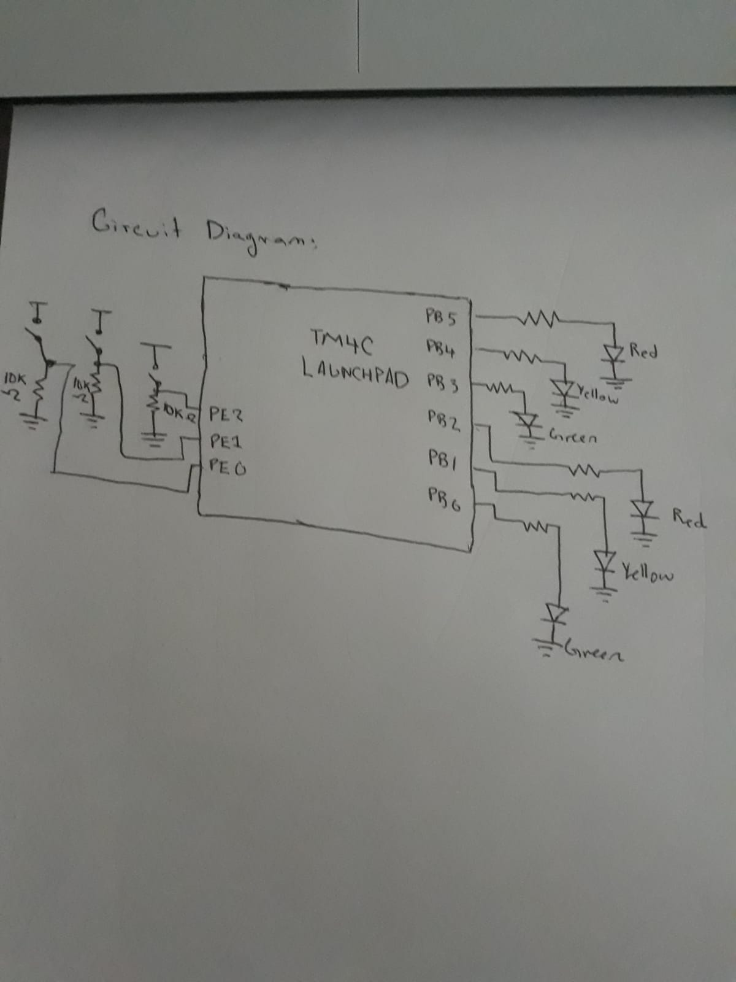

***PART B: Logic Analyzer***

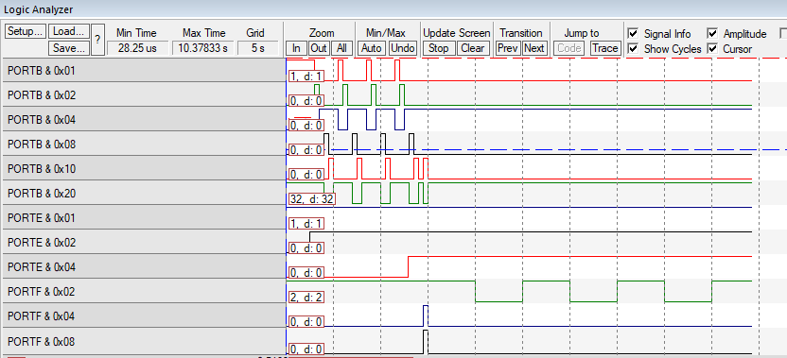

***PART C: Drawing of Finite State Machine***

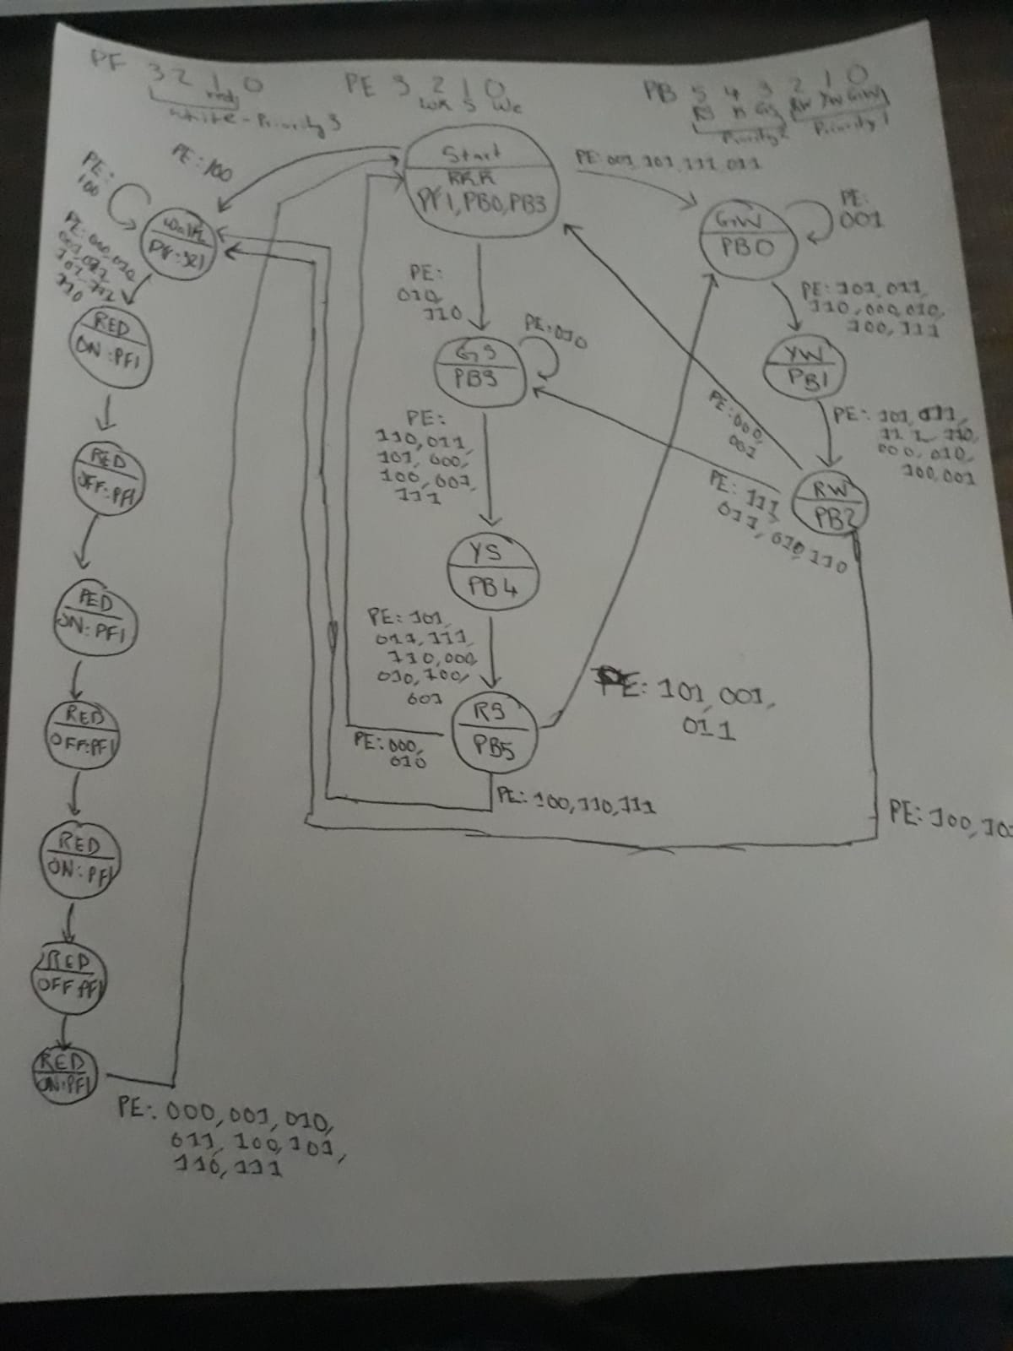

***LAB 5 DEMONSTRATION QUESTIONS***

1. How does the SysTick_Wait function work, and how do you add more input signals and/or output signals?

SysTick_Wait → implementation of delays & can be a countdown timer → counts down on the bus cycle (24-bit counter decrements at bus clock frequency)

You can add more input/output signals by adding them to the FSM

2. How could you experimentally prove your system works (What data should be collected and how would you collect it?) If there were an accident, could you theoretically prove to the judge and jury that your software implements an FSM?

3. What type of FSM do you have?

Moore FSM

4. What other types are there?

Mealy

5. How many states does it have?

18 states

6. In general, how many next-state arrows are there?

Total: number of next states * number of states

7. Explain how the linked data structure is used to implement the FSM?

The linked data structure allows us to flow through the steps easily, from one state to the next based on set conditions (inputs).

8. Explain the mathematical equation used to calculate the address of the next state, depending on the current state and the input?

Mathematical Equation is essentially derived from state transition table > boolean equation

9. Be prepared to write software that delays 1 second without using the timer (you can use a calculator and manual) How do you prove the delay will be 1 second? What does it mean for the C compiler to align objects in memory? Why does the compiler perform alignment?

Am prepared.

10. List some general qualities that would characterize a good FSM?

No state is “starved” of transitions. I.e. there are all possibilities addressed in each state’s transition to the next. Each state also has some condition of output that is different from its previous one, unless its looping back, or going back to initialization.

11. If an LED does not activate, how could you tell if the mistake is the electrical circuit or software?

Use the simulator.

12. If there is an accident at the traffic light and both parties claim they had a green light so they want to sue you, the traffic light designer, for making a faulty system. How would you prove that at the time of the accident that your system was behaving properly?

Recreate the condition pre-accident, and test it on the same code. If the delay times were off, that is the responsibility of the civil engineer. Either use the simulator or test it again with the same system in place.